You can disable driver signature enforcement by using these steps:

1. Start Command Prompt as administrator.
2. When Command Prompt starts enter the following lines:
   * **bcdedit.exe -set loadoptions DISABLE_INTEGRITY_CHECKS  
     [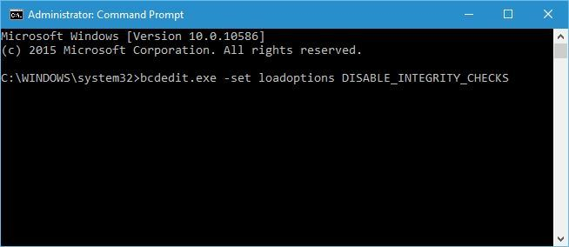](https://cdn.windowsreport.com/wp-content/uploads/2016/07/driver-signature-enforcement-disable-1.jpg)**
   * **bcdedit.exe -set TESTSIGNING ON  
     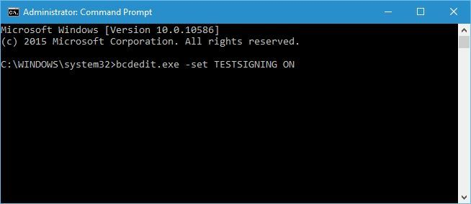**
3. Close Command Prompt and restart your PC.
4. Optional: To enable driver signature enforcement open Command Prompt as administrator and enter the following:
   * **bcdedit -set loadoptions ENABLE_INTEGRITY_CHECKS****[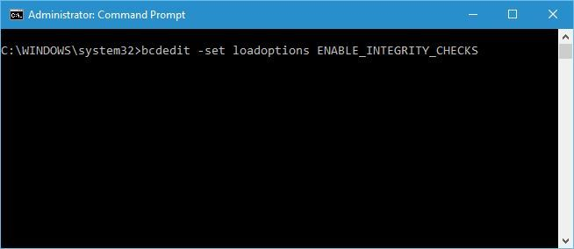](https://cdn.windowsreport.com/wp-content/uploads/2016/07/driver-signature-enforcement-enable-1.jpg)**
   * **bcdedit -set TESTSIGNING OFF  
     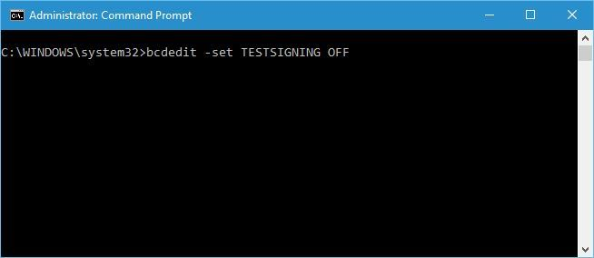**

Bear in mind that using this solution will disable driver signature enforcement permanently, thus making your computer somewhat vulnerable.

Driver signature enforcement is a useful feature that provides extra protection, but sometimes extra protection can cause problems when installing certain drivers. We hope that you now understand how driver signature enforcement works and how to disable it in Windows 10.